## Instructions for using the mapping file

You should have a brand new folder[1], named after your specification, in the specifications subfolder of the Bioschemas google docs folder. That folder should contain a copy of this file and a google spreadsheet. Your new spreadsheet looks like this:

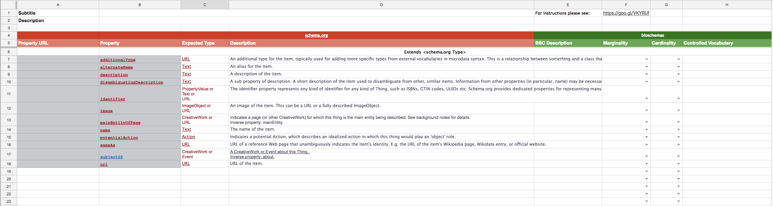

You will find a link to these instructions in cell E1.

To create your specification you must populate the spreadsheet by doing the following:

* Set up the spreadsheet
* Add specialised descriptions, marginalities and cardinalities
* Add CVs
* Trigger the generation process

Each step is discussed in-depth below.

Important note: column A should be empty unless you are using a property from an existing, external ontology. Continue reading for more information.

### Set up the spreadsheet

**In cell B1** please put a very short description of your new profile. For example, *Specification describing a gene*.

**In cell B2** please enter a longer description of your new profile. Whilst there is no limit on size, please be mindful that it should give a brief overview of why your profile exists and what it covers. A couple of paragraphs should be sufficient.

**In row 6** please enter the name of the Schema.org type on which you have based your specification, e.g., *Course* or *CreativeWork*. If you are unsure of what types schema includes, please familiarise yourself with them: <http://schema.org/docs/full.html>. If this new specification is not based on any pre-existing schema.org type please enter *Thing*.

**Cells B7 - D18** contain the properties of <http://schema.org/Thing>; they have been copied from the schema site and pasted into Cell B7. Do not edit cells A7 - D18.

Unless your group is basing its specification on <http://schema.org/Thing>, **cell B19** should contain the properties of the schema.org type entered in row 6. Go to the appropriate schema.org web page, select all the properties in that type before copying them and pasting them into B19. You should not copy properties from *Thing*, but all other Types on the page should have their properties copied across.

**In the next available row** start entering brand new properties (i.e., properties that are not found in schema.org). Each property should have a name (in the *Property* cell), *Expected Type* (i.e., a schema.org or bioschemas type), but leave the *Description* cell blank.

If you wish to use a property from an existing ontology, enter the URL of the property in **column A**, and a human readable name in **column B**. For example,

A: <http://purl.obolibrary.org/obo/RO_0002327>

B: enables

At the bottom of the page you will see three tabs:

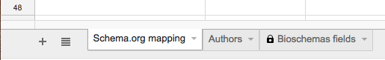

Switch to the *Authors* tab, at which point you will see a new table. Please use this table to record who has contributed to the creation of this specification.



### 

### Descriptions, Marginalities & Cardinalities

Switch back to the *Schema.org mapping* tab.

Only those properties for which you specify a marginality and a constraint will appear in the published specification.

Your group must consider each property (i.e., row) individually. Start by classifying each property as one of the following:

* Irrelevant - in which case do nothing, it will automatically be ignored
* Might be useful - use the list box in the *Marginality* cell to select *Optional*
* Probably useful - use the list box in the *Marginality* cell to select *Recommended*
* Essential - use the list box in the Marginality cell to select *Minimum*

Ignoring irrelevant properties, use the *BSC Description* cell to describe how your property should be interpreted from a Bioschema’s perspective. Your group has several options:

* You agree with the schema.org description, and it perfectly describes your intentions: please leave the cell empty.
* You mostly agree with the schema.org description: copy the content from the *Description* cell into the the *BSC Description* cell and edit the *BSC Description*.
* Anything else: write some brand new text in the *BSC Description* cell.

Please do not edit the text in the *Description* cell.

Still ignoring the irrelevant properties, determine how many times each property is needed in a single instance of your specification. You have two options:

* Only once - use the list box in the *Cardinality* cell to select *ONCE*
* May require multiple occurrences - use the list box in the *Cardinality* cell to select *MANY*

Once you have completed the BSC Description, Marginality and Cardinality cells for every relevant property (row) you can switch to the third tab (*Bioschemas fields*) to see exactly what you have selected. If you are happy with your specification you are ready to trigger the generation process.

### Add CVs

If you do not wish the property to use a controlled vocabulary then leave this cell blank.

If you wish to specify your own list of terms, then enter these terms like so:

*LIST - term1, term two, a third and final term*

Note: the use of a comma to separate each term.

If you wish to use terms from an existing CV, enter the information as follows:

*ONTOLOGY - abbreviation*URL, abbreviation2:*URL2*

For example,

*ONTOLOGY - EDAM:Operation*http://edamontology.org/operation_0004, ECO*https://www.ebi.ac.uk/ols/ontologies/eco*

### Trigger the generation process

Please email [kcm1@hw.ac.uk](mailto:kcm1@hw.ac.uk), cc’ing the mailing list to have your specification on the website updated.

### Extra information

Versioning: the assignment of version numbers is determined by the process. When you first ask for your gSheet document to be converted into a specification, it will be published on <http://bioschemas.org/specifications/drafts>. It will automatically receive the version number v0.1-draft.1. The next time you ask for the specification to be updated the version will become v0.1-draft.2. This will continue indefinitely.

When it is determined your specification is sufficiently mature to be published as a release version (on <http://bioschemas.org/specifications>) the version number will become v0.1.

Subsequent minor changes will be published on the drafts page, where the version number will be v0.2-draft.1. Again, once mature the specification will be published on the <http://bioschemas.org/specifications> page with version set to v0.2.

This iterative process may continue indefinitely.

1. If this is not true, please email for assistance.